**IBM NAAN MUDHALVAN DATA ANALYTICS WITH COGNOS**

**PHASE 3**

**DEVELOPMENT PART -1**

Student Name:R.Lavanya

Register Number:620821104055

Branch: B.E- CSE

Year: IIII Year

Topic: Air Quality Analysis in Tamilnadu

Title: Data Analytics Cognos

College: Gnanamani College Of Technology

**INTRODUCTION**

Air quality analysis is a critical endeavor aimed at understanding the composition of the atmosphere and assessing the presence of pollutants that can have adverse effects on human health, ecosystems, and the environment. In the context of Tamil Nadu, a state in southern India known for its diverse geographical and industrial landscapes, monitoring and analyzing air quality is of paramount importance.

Tamil Nadu is home to a burgeoning population and a variety of industries, including manufacturing, automotive, and technology. This dynamic combination of factors presents unique challenges related to air quality, as increased urbanization and industrialization can lead to elevated levels of air pollutants.

The development of air quality analysis in Tamil Nadu is a multifaceted and ongoing process that encompasses various aspects, from data collection and preprocessing to advanced modeling and policy recommendations. It is a collaborative effort involving government agencies, environmental organizations, researchers, and technologists working together to ensure the well-being of Tamil Nadu's residents and the preservation of its natural resources.

**Objectives**

* Evalute the impact of poor air quality on public health, including respiratory diseases and cardiovascular problems.
* Analyze historical air quality data to identify trends and changes pollution levels over time.
* Develop and recommend strategies and policies to mitigate air pollution, which may include emissions reduction measures, traffic management.

**Data Source**

TNPCB monitors air quality across the state and provides data on pollutants like PM2.5, PM10, sulfur dioxide (SO2), nitrogen dioxide (NO2), carbon monoxide (CO), and ozone (O3). They often have monitoring stations in major cities.

**Dataset Link:**  <https://www.kaggle.com/datasets/fedesoriano/air-quality-data-set>

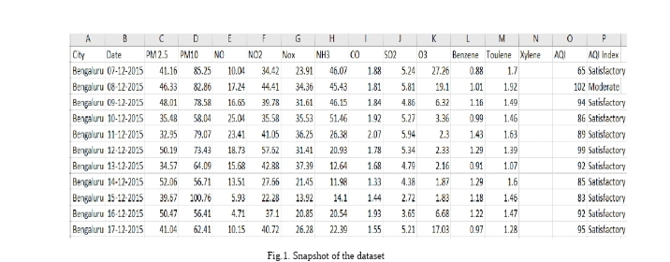

**Data Loading**

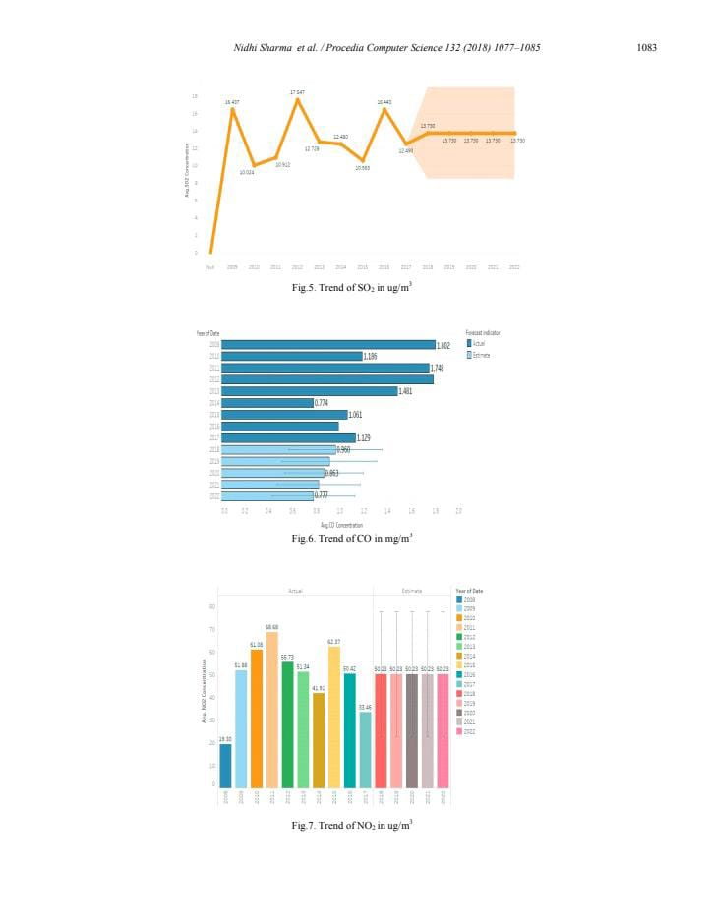

* Data collection
* Data preprocessing
* Data integration
* Data analysis
* Data cleaning

**Data collection**

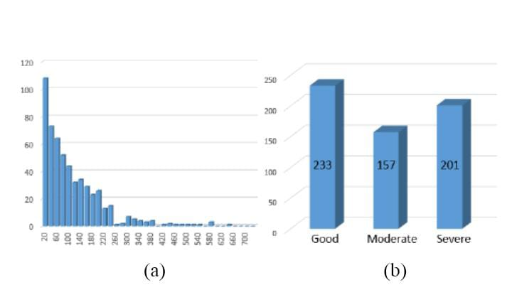

**Data preprocessing**

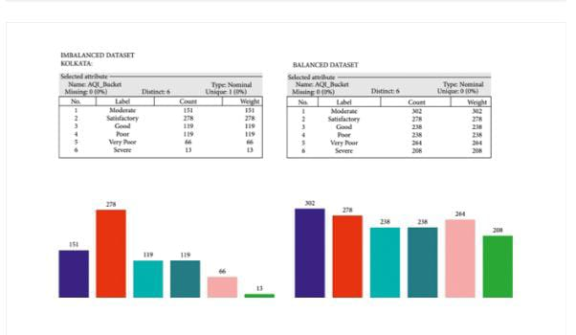

**Dashboard creation**

* Select a Dashboard Platform
* Data Integration
* Geospatial Visualization

**Select a Dashboard Platform**

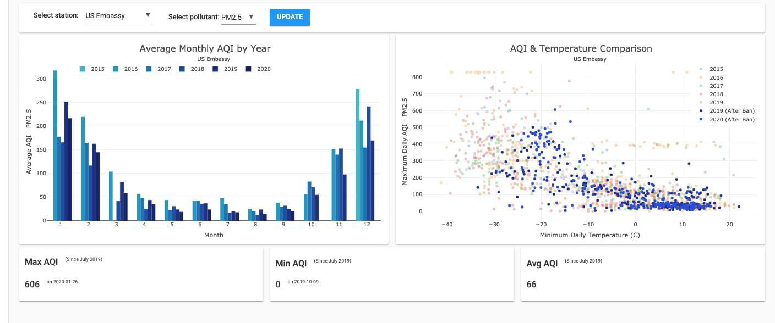

**Geospatial visualization**

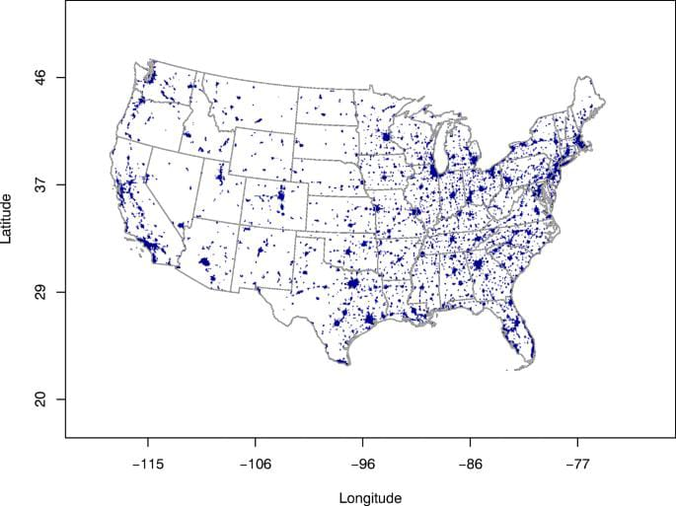

**Conclusion**

Air quality fluctuations in tamil nadu can result from various factors, including weather conditions, industrial activities, vehicular emissions, and natural events like forest fires. To address these convulsions in air quality analysis.

Data analysis: Implement advanced data analysis techniques to detect trends and anomalies in air quality data.

Research: Invest in research to understand the specific sources of air pollution in different regions of tamil nadu and develop targeted solutions.

* These measures can help mitigate the convulsionsin air quality and improve the overall environmental health in the state.